Title – To Do App

Name – Anshdeep Singh

Student ID – 300351832

I am confirming that I have completed the classwork assignment completely based on the requirements and it is working and fully functional.

The user can add, delete, update the tasks and swipe features are also working.

Output:

 

Code:

MainActivity class

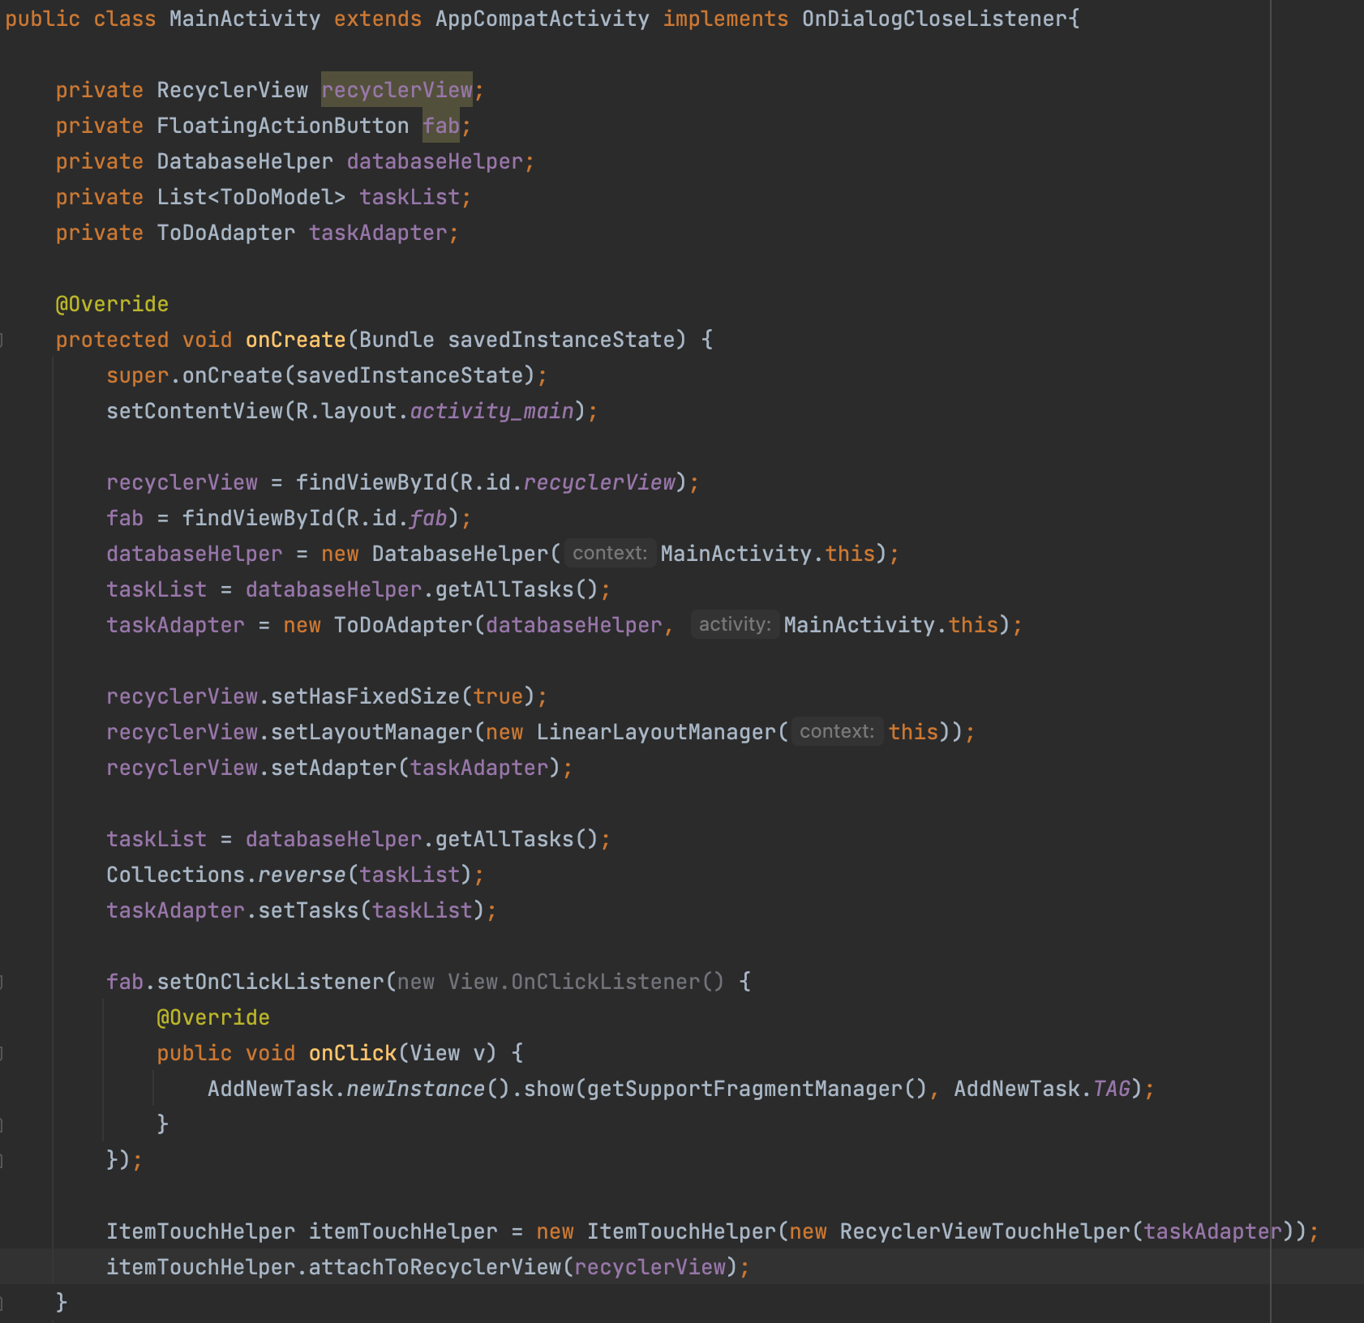

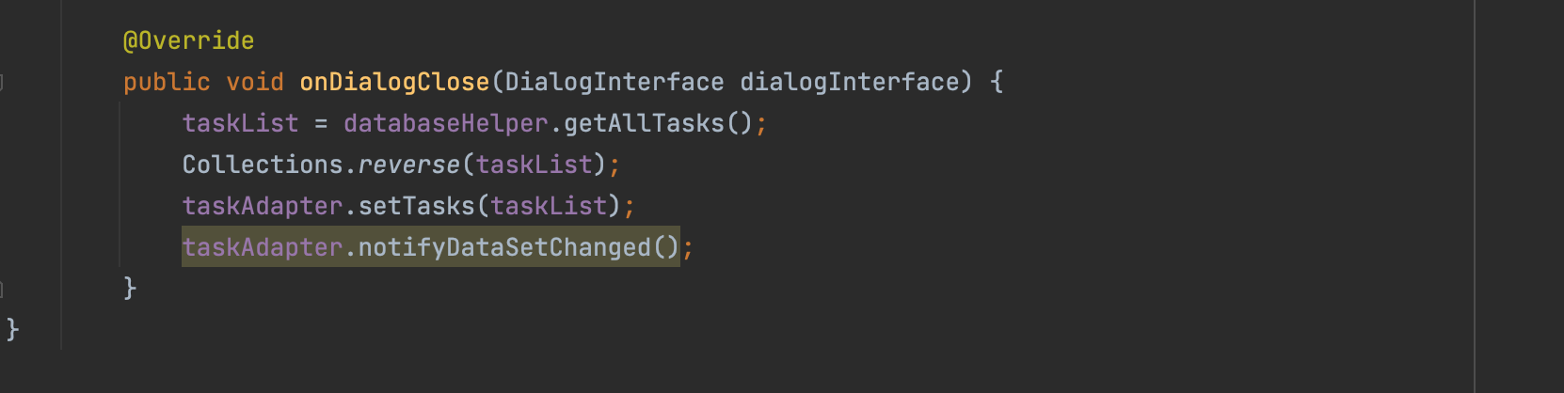

Splash Activity

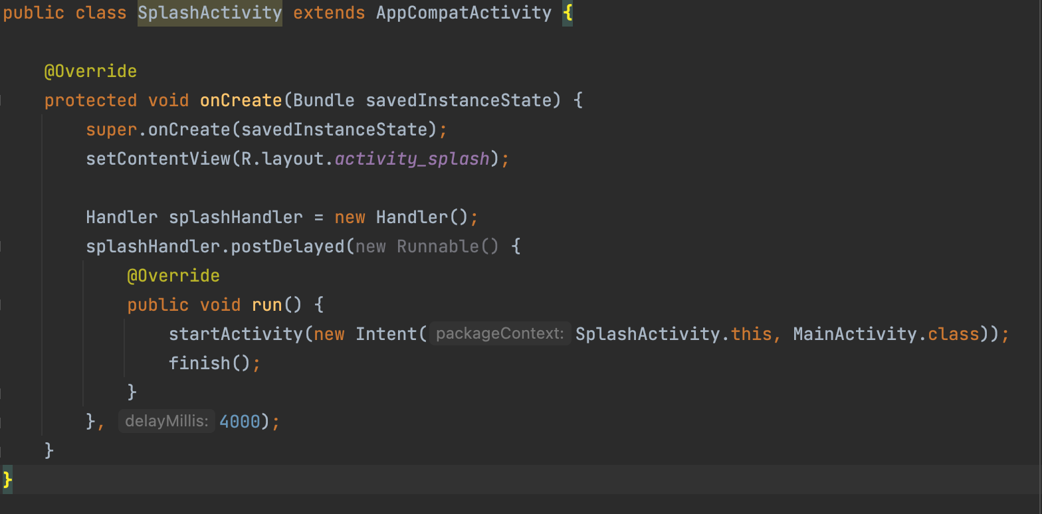

AddNewTask

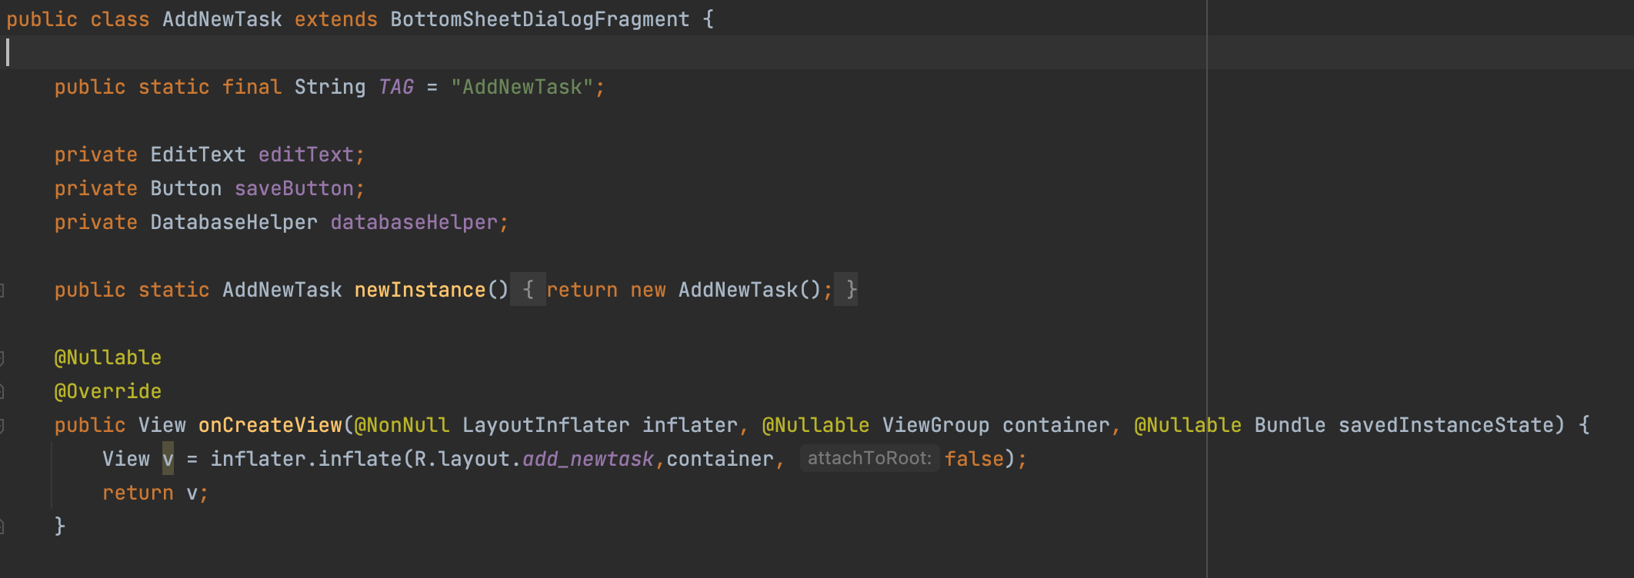

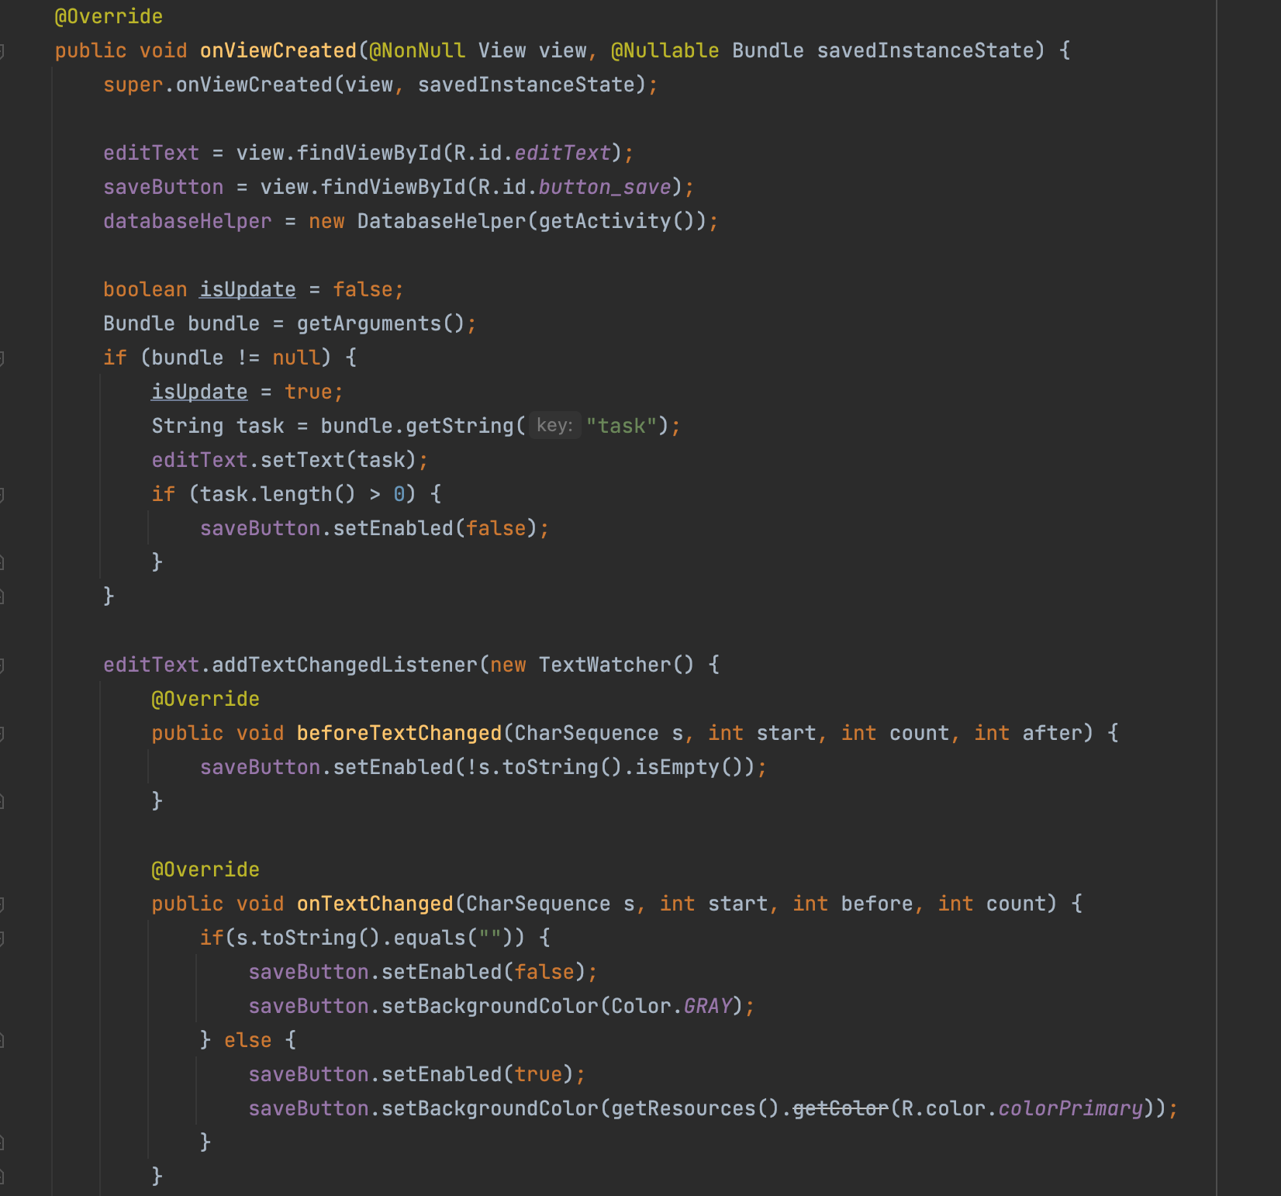

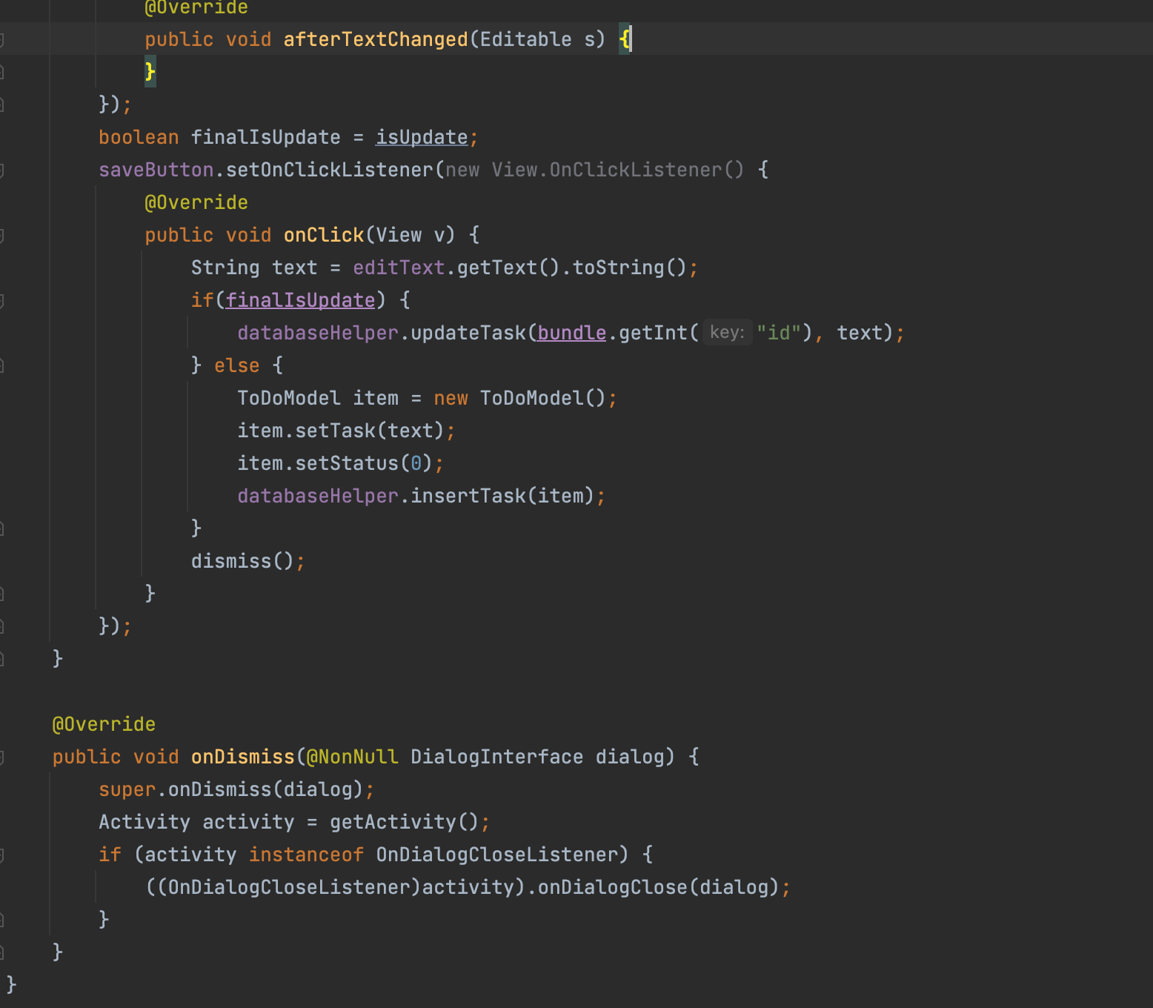

RecyclerViewTouchHelper

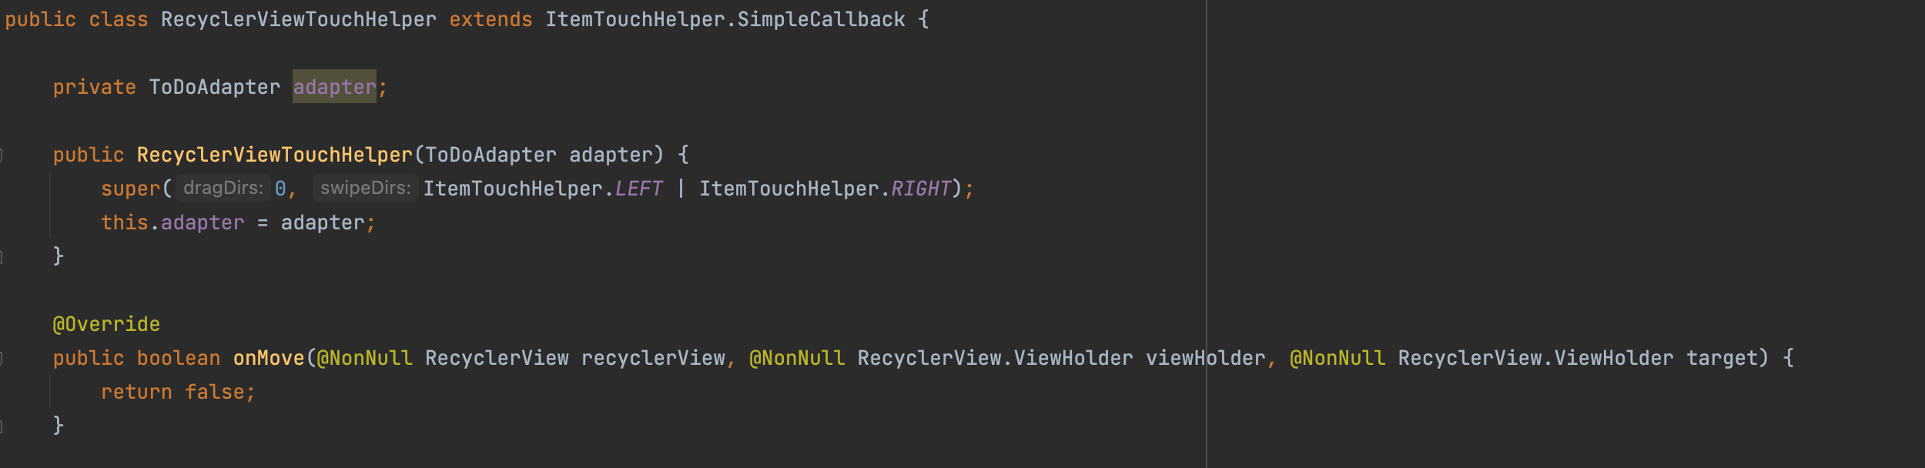

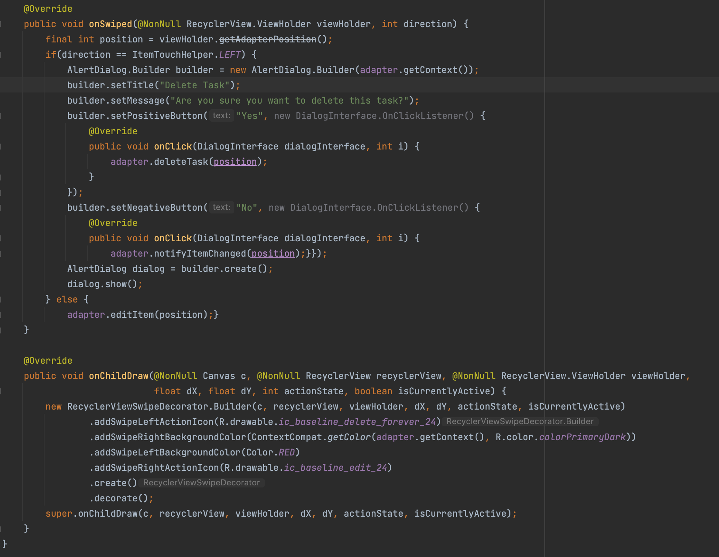

DatabaseHelper

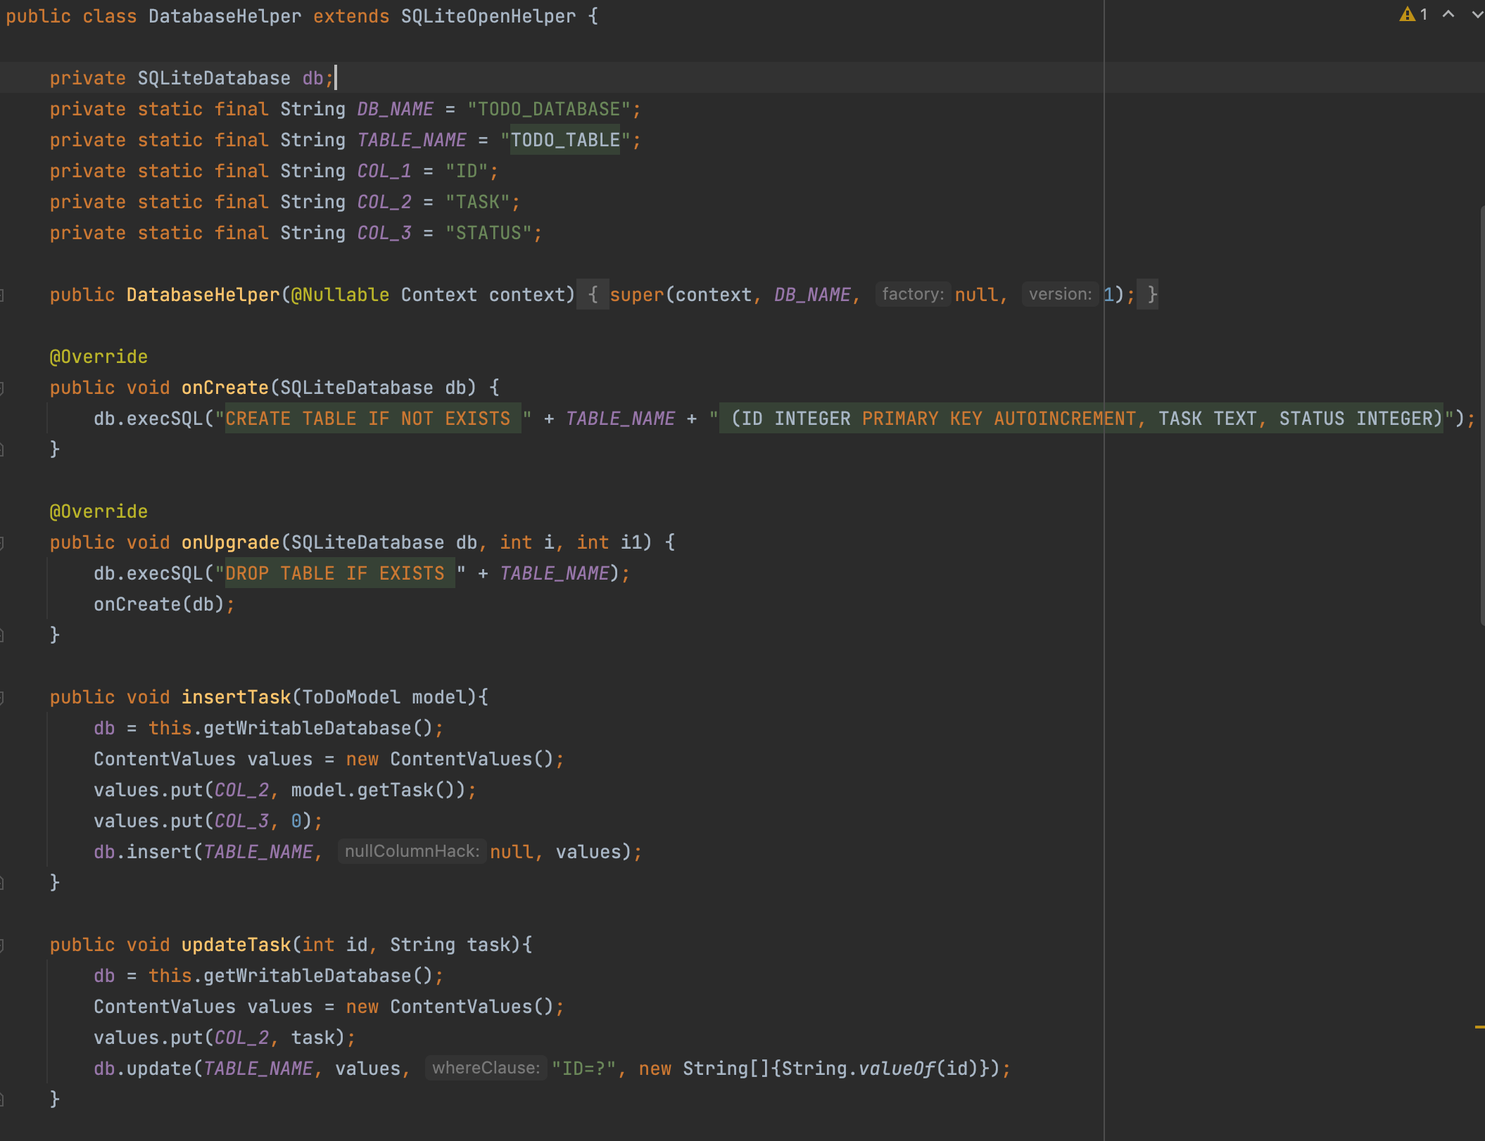

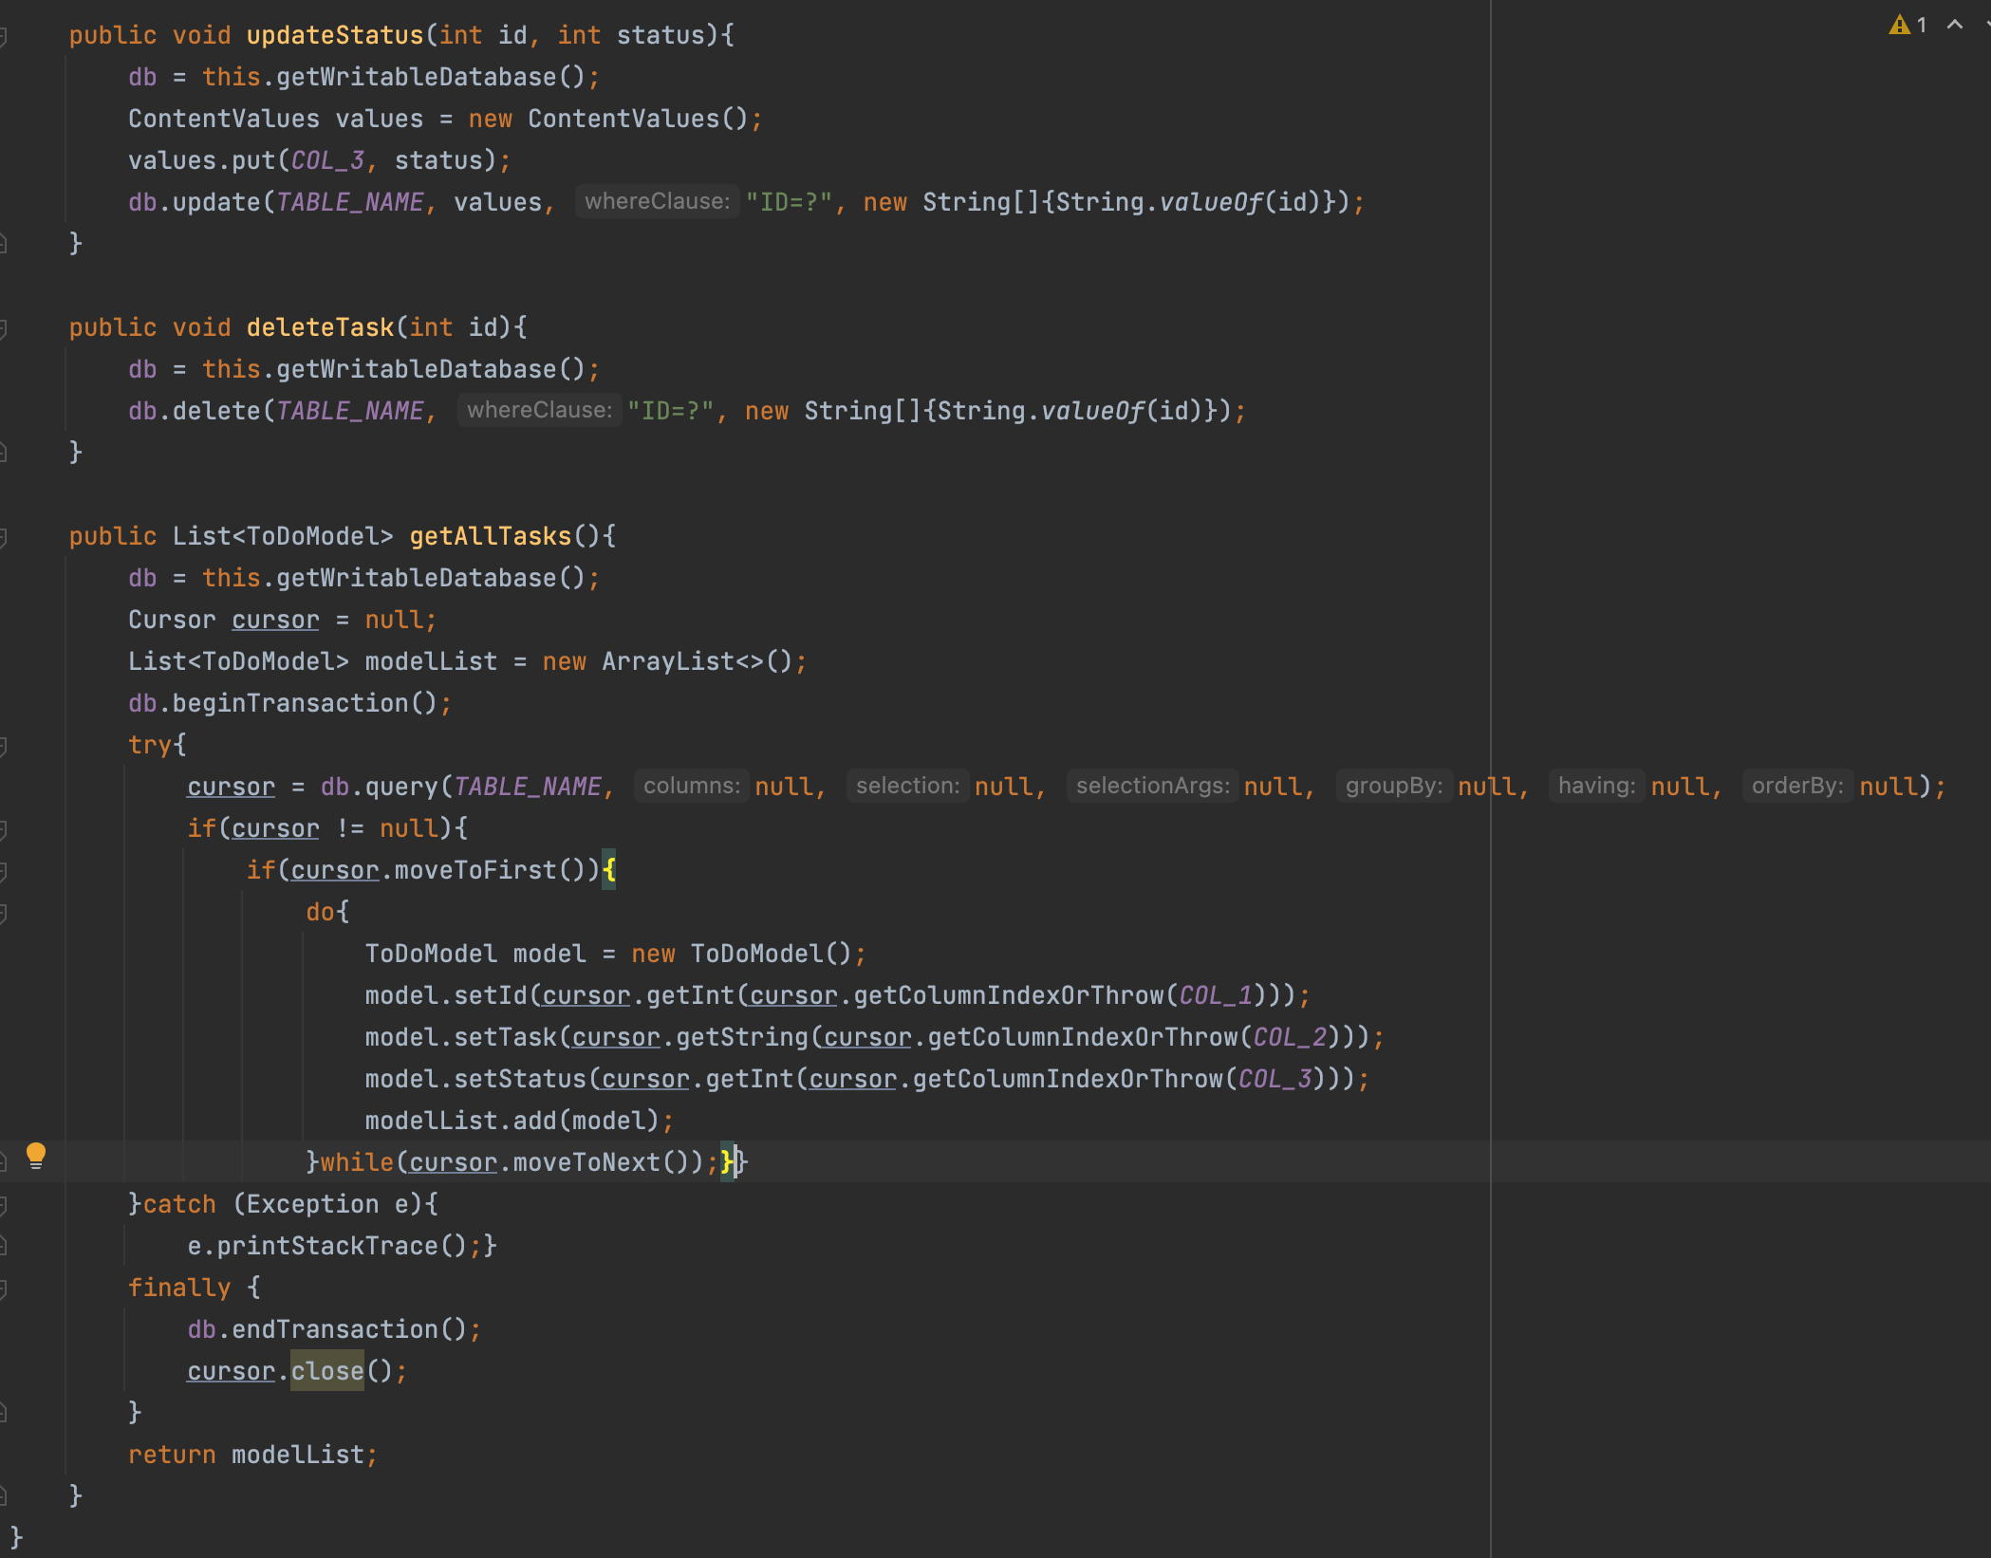

ToDoModel

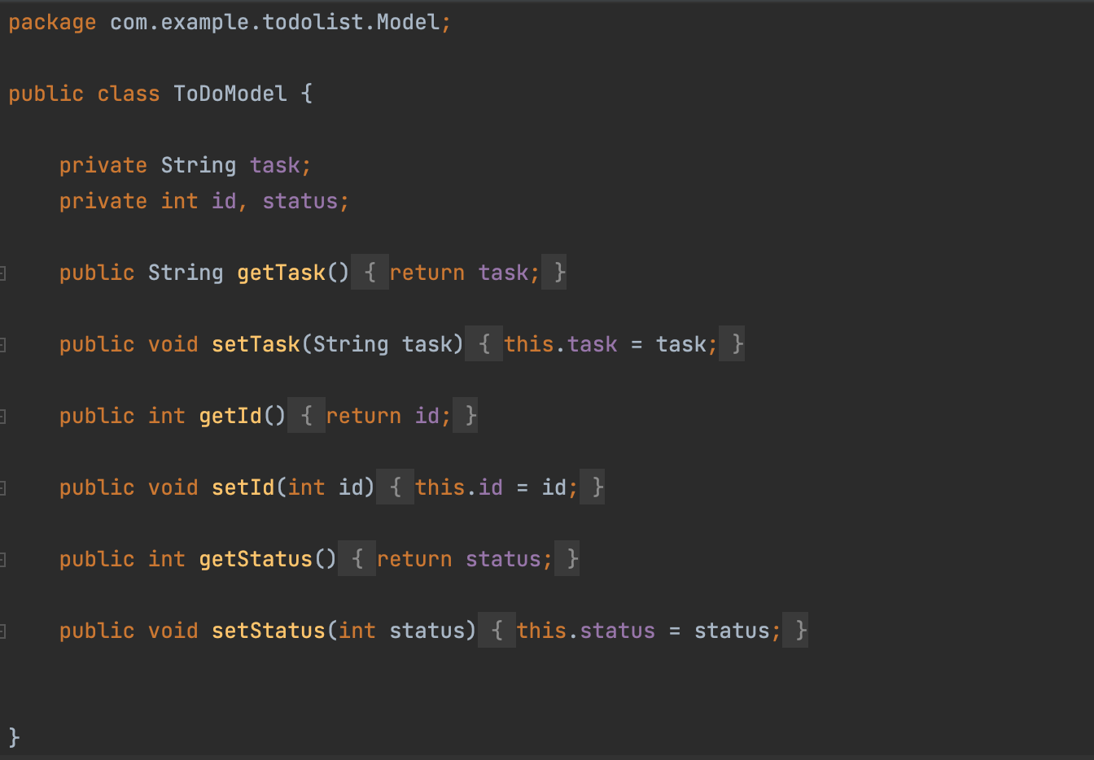

ToDoAdapter

